Unreal Engine FBX Test Builder

Creating a FBX Test Plan

- Add the FBXAutomationTestBuilder plugin

- After restarting the FBX Test Builder tool can be found at "Tools>Debug>FBX Test Builder".
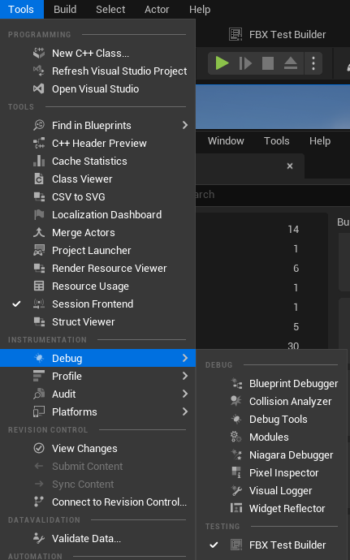
- Select a FBX file from the drop down. Select a testplan> Create a test plan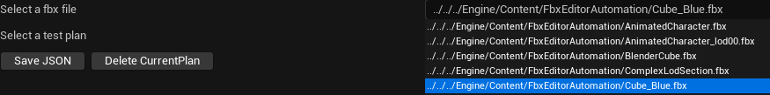

- Set a test plan name.
- Select the action you would like to test.
- Under the expected results you can add an array element where you can select the data you wish to check and the expected value it should have. For the Cube_Blue.fbx we can check that there is 1 LOD and that there are no errors when importing. 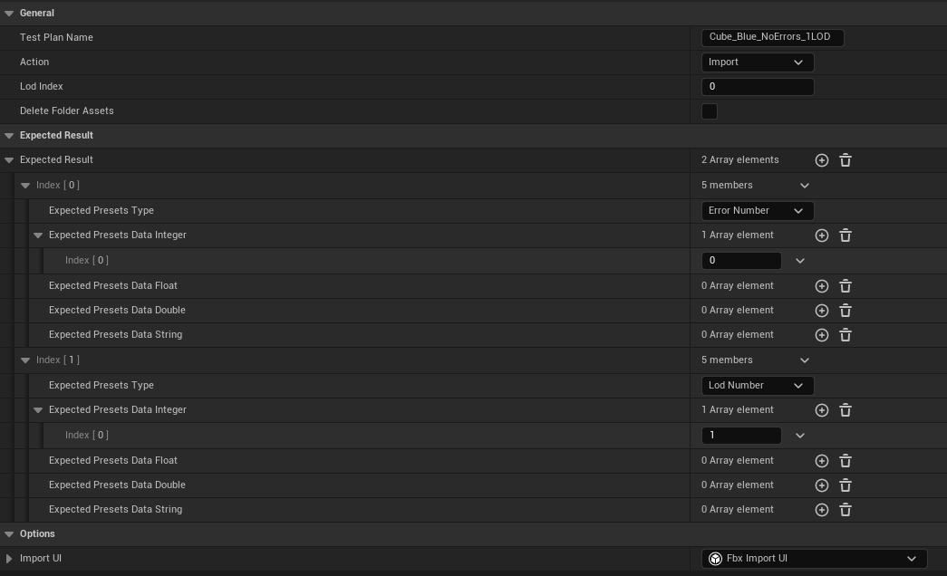
- Save the test plan. Tests can then be located in the session frontend under:
Editor>Import>Fbx>*FBX Name*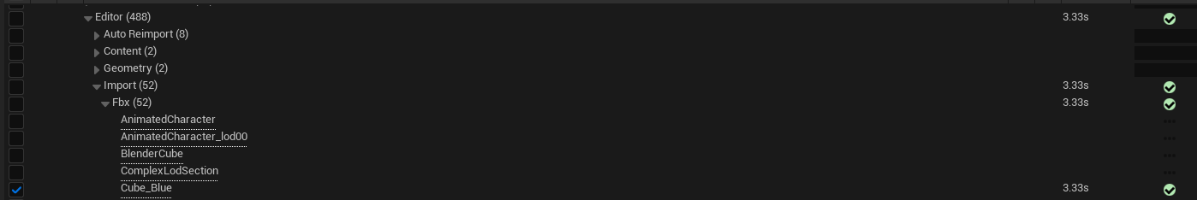
- If you get some warnings saying it couldn’t be loaded (usually if run a second time straight away) ensure all files are saved before running the test.

Testing a specific FBX model

- Source an FBX Model.
- Navigate to the Unreal Engine Root directory.
- Navigate to “/Engine/Content/FBXEditorAutomation”
- Place the FBX file in the FBXEditorAutomation folder.
- The FBX model should now be accessible in the FBX file dropdown in the FBX Test Builder.

